Biolinks Alliance
Chair’s Report, October 2019
It’s been another progressive year for Biolinks Alliance, and I continue to feel lucky and privileged to be working with such a passionate and talented group of conservationists committed to seeing central Victoria’s amazing environment protected for future generations. We have: further improved our capacity to secure independent funding; hosted leading conservation biologist and researcher Dr. Peggy Eby in another successful fundraiser in Bendigo (Nomadic Nectar–feeding Birds and Bats – ‘Australia’s Great Wildlife Migrations’); staged our fourth high–quality symposium in Euroa, ‘Bolstering the Refuges’; and developed a new organisational Strategic Plan – increasing our focus on working with member groups to fund and implement landscape-scale conservation projects, such as Glideways and Restoring Lost Landscapes.
This shift to investing more in projects has been a long time in the making, but the Board is united in the view that large landscape–scale conservation projects are needed now, more than ever. As humanity grapples with the profound challenge of holding global warming within 1.5°C, big and bold nature–based climate solutions are increasingly being given more attention for their potential to draw–down carbon, while also enhancing food security, water supply and biodiversity. In March of this year the United Nations announced the UN Decade of Ecosystem Restoration, which aims to massively scale–up the restoration of degraded and destroyed ecosystems. We strongly believe Biolinks can help catalyse this sort of change here in central Victoria. Through our projects we aim to collaborate with the community to begin this shift towards a more sustainable future. We have already commenced Glideways projects in the Strathbogies, Broadford and Macedon Ranges regions, aimed at restoring habitat and connectivity for threatened gliders. We are also using new techniques to help revive grasslands, repair the damaged inflicted on woodlands and forests in the goldfields, and to restore platypus habitat in concert with philanthropists, communities, academics and Traditional Owners.
I would like to warmly thank our generous donors and sponsors, without whose support our work would not be possible. I would also like to thank the Board, especially our hard-working Secretary Peter Mitchell. Two retiring Board members have made a wonderful contribution, namely: Karen Alexander – a fearless founding Biolinks advocate and convenor of the Fundraising Committee; and James Nelsson representing the North Western Goldfields and Loddon Plains region. New members this year are Treasurer Pat Scanlon, Lachlan McIntyre and Peter Evans.
Thanks must also go to our amazing, dedicated staff: Sophie Bickford, Linda Parlane and Ellie McKenna; as well as to all the speakers at our Symposium and special events, plus our valued member groups and volunteers.
We are indebted to you all. Thank you for helping to make the Biolinks dream become a reality, and protecting what is unique about central Victoria. I look forward to continuing working together with you. Our very future depends on it.

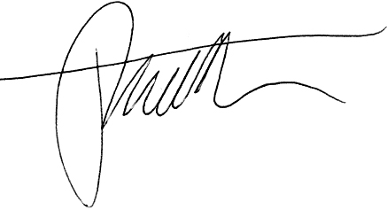
Paul Foreman
Chair / Biolinks Alliance
0429 009 743
biolinksalliance.org.au

